Variation in Diagnosed Diabetic Eye Disease Across Risk-Factor Subgroups in a Commercially Insured Population

Research Question and Motivation
This project examines variation in diagnosed diabetic eye disease across risk-factor subgroups in a commercially insured population. The primary research question is: How does the prevalence of diagnosed diabetic eye disease differ across risk-factor subgroups within a commercially insured population? A secondary research question is: Do state-level behavioral risk patterns, such as adult obesity and physical inactivity, provide context for geographic variation in diagnosed diabetic eye disease?
Diabetes-related eye disease is an important public health problem because it can lead to preventable visual impairment and blindness if it is not detected and managed in time. Diabetic retinopathy and diabetic macular edema may progress without early symptoms, meaning that patients may not recognize disease progression until vision loss becomes more serious. National surveillance estimates show that diabetic retinopathy affects a substantial number of people with diabetes in the United States, and the CDC Vision and Eye Health Surveillance System is a major public source for estimating the burden of diabetic retinopathy and related eye conditions (1).
This project builds on prior research showing that diabetic retinopathy remains a major health burden in the United States. Lundeen et al. reported that the estimated number of people with diabetic retinopathy and vision-threatening diabetic retinopathy has increased substantially over time, highlighting the continuing importance of diabetes-related eye disease surveillance. This evidence suggests that diabetes-related eye complications remain an important clinical and public health concern, even in settings where healthcare coverage and diagnostic services are available (2).
The motivation for this project shifted slightly during exploratory analysis. The original project idea was broader and focused on preventive eye care access. However, after reviewing the available variables in the MarketScan Commercial Medical Insurance dataset from the Vision and Eye Health Surveillance System, the analysis became more focused on diagnosed diabetic eye disease prevalence and how that prevalence varied across risk-factor and geographic subgroups. This shift was appropriate because the available claims-based summary data directly captured diagnosed eye disease indicators, risk-factor categories, state, year, age, sex, and other subgroup variables, but did not provide individual-level clinical information such as HbA1c values, diabetes duration, or detailed screening adherence.
The healthcare significance of this question is that subgroup and geographic variation can help identify populations with higher diagnosed disease burden. For insurers and employers, understanding these patterns may support prevention strategies and management programs for commercially insured adults. For clinicians and eye care providers, the results may highlight the importance of screening and follow-up among patients with diabetes and related risk factors. For public health researchers, this project demonstrates how claims-based surveillance data can be combined with behavioral surveillance data to describe geographic patterns in diabetes-related eye disease.

Data sources:
The primary data source for this project was the Commercial Medical Insurance (MSCANCC) dataset from the CDC Vision and Eye Health Surveillance System (VEHSS). This dataset contains de-identified summary measures of vision and eye health indicators based on MarketScan Commercial Claims and Encounters data. The MarketScan Commercial Claims and Encounters data include insurance claims information from people with employer-sponsored commercial insurance and their dependents. CDC describes the MarketScan data as a convenience sample of commercial claims data (3).
The dataset was obtained from the CDC public data portal. Each record in the primary dataset represents a stratified summary observation for a specific eye health indicator. The Unit of observation is not an individual patient; instead, each row represents a summary measure defined by combinations of variables such as year, state, question, risk, factor, risk-factor response, age group, sex, race. /Ethnicity, and other stratification fields. Key variable used in this project include year_start, state_abbr, question, Risk_factor, risk_factor_response, age sex, and data_value. The main outcome variable was the prevalence estimated for diagnosed diabetic eye disease. The temporal coverage in the working dataset includes years such as 2016, 2020, and 2023, depending on the specific measure and subgroup availability.
The source contributed directly to the main research question because it contained claims-based summary estimated of diagnosed diabetic eye disease in a commercially insured population. It also included subgroup variables that allowed descriptive comparison across risk-factor responses and states. Because the project focused on commercially insured populations, that dataset was more aligned with research question that a general population survey alone.
The supplementary data source was the Nutrition, Physical Activity, and Obesity – Behavioral Risk Factor Surveillance System dataset from CDC. This dataset includes public health indicators related to adult diet, physical activity, and weight status, using data from the Behavioral Risk Factor Surveillance System. BRFSS is a state-based telephone survey that collects self-reported information about health conditions and health behaviors among adults(4).
A key change from the original proposal was that the BRFSS dataset was used only as a contextual and ecological source, not as an individual-level risk-factor dataset. Because the MarketScan and BRFSS datasets cannot be linked at the patient level, the supplementary source was used to examine state-level correlations rather than individual associations.

Data Integration and Analysis Methods
The project used a descriptive, repeated cross-sectional design based on publicly available summary data. The primary analysis focused on variation in diagnosed diabetic eye disease prevalence within the MarketScan claims summary dataset. The supplementary analysis explored whether state-level behavioral indicators from BRFSS were associated with state-level diagnosed diabetic eye disease prevalence.
The two datasets were integrated at the state-year level where possible. The main join keys were state abbreviation and year. In the MarketScan dataset, the state variable was represented by state_abbr, and the year variable was represented by year_start. In the BRFSS dataset, the state variable was represented by location_abbr, and the year variable was represented by year_start. These variables were used to join the datasets.
A left join was used to preserve all MarketScan state-year records. After the join, unmatched or incomplete records were identified. The joined dataset contained 94 records, 48 states, and 2 years. Five records had missing BRFSS obesity and physical inactivity values, including records for Kentucky, Pennsylvania, Florida, and records labeled as missing location. After removing records with missing values for diabetic eye disease prevalence, obesity prevalence, or physical inactivity prevalence, the final complete-case analytic dataset included 89 records.
Several data cleaning steps were required. In the MarketScan dataset, the analysis was restricted to the question “Annual prevalence of diagnosed diabetic eye diseases” and the response “All Diabetic eye diseases.” To reduce complexity and avoid mixing multiple subgroup definitions, the dataset was filtered to state-level records for all ages, both sexes, all races, diabetes as the risk factor, and risk-factor response equal to “Yes.” In the BRFSS dataset, the analysis selected indicators related to adult obesity and no leisure-time physical activity. These indicators were reshaped from long format to wide format so that each state-year record contained both behavioral variables.
The main analytical methods were descriptive statistics, visualization, Pearson correlation analysis, and simple linear regression. A bar chart was used to show state-level variation in diagnosed diabetic eye disease prevalence. Scatterplots with fitted regression lines and 95% confidence bands were used to examine ecological associations between BRFSS behavioral indicators and MarketScan diabetic eye disease prevalence. Simple linear regression models were used to estimate the direction and strength of association between adult obesity prevalence, physical inactivity prevalence, and diagnosed diabetic eye disease prevalence at the state-year level. A Pearson correlation heatmap was also created to summarize the relationships among the three main analytic variables.
The analysis was conducted in R. The main tools included readr for data import, dplyr for filtering and data transformation, janitor for cleaning variable names, tidyr for reshaping data, and ggplot2 for visualization. These tools supported a reproducible workflow that could be included in the supplementary materials for the final project.

Key Findings

Finding 1: Diagnosed diabetics eye disease prevalence varied substantially across states.
The first major finding was that diagnosed diabetics eye disease prevalence was not uniform across states. After filtering the MarketScan dataset to selected diabetic eye disease measure and broad demographic categories, the bar chart showed visible state-level differences in prevalence. Some states had noticeably higher diagnosed prevalence, while other had lower prevalence.
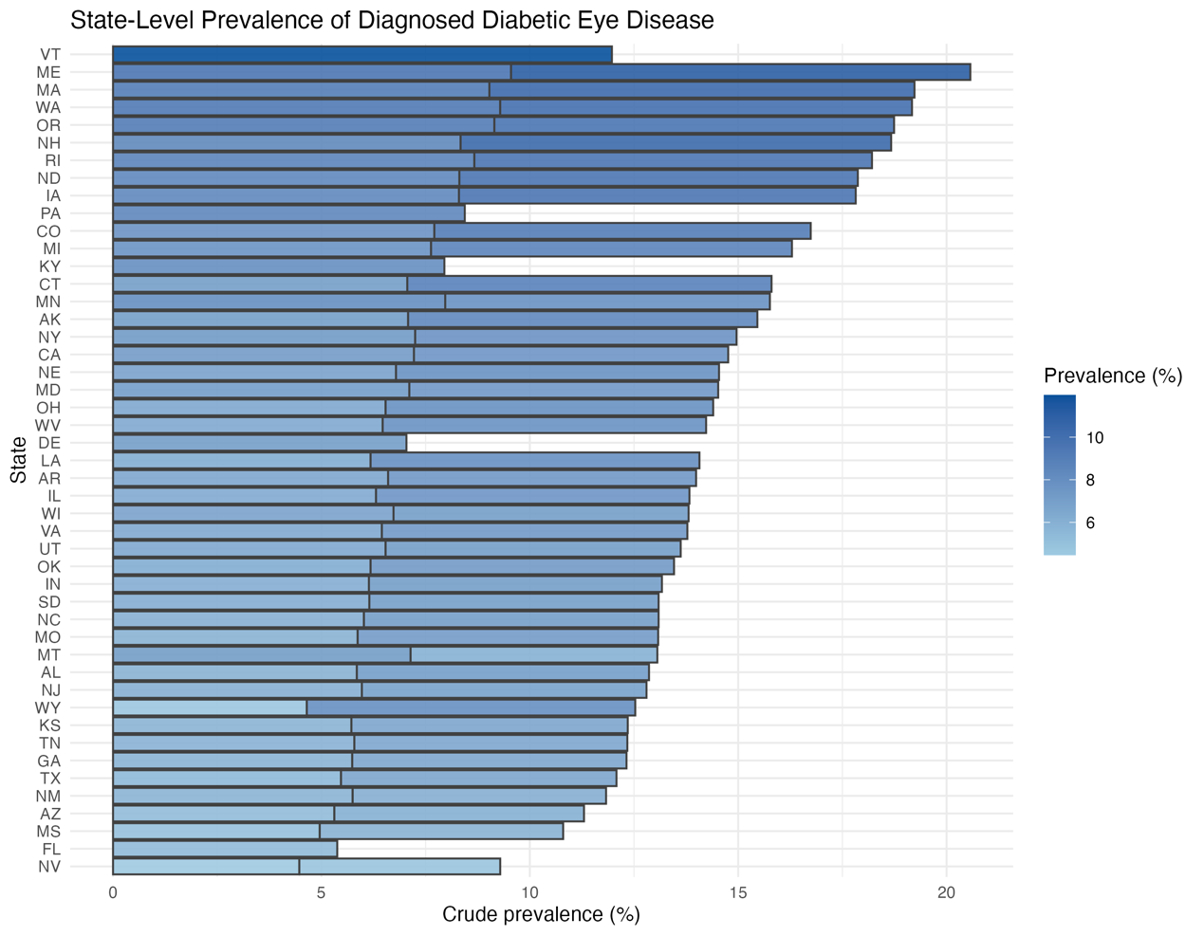
Figure 1. State-Level Prevalence of Diagnosed Diabetic Eye Disease
This finding directly addresses the primary research question by showing that the burden of diagnosed diabetic eye disease differs geographically within the commercial insured population. The result suggests that commercial insured coverage does not produce a uniform pattern of diagnosed disease across the country. Differences also reflect differences in healthcare utilization, coding practices, screening patterns, access to eye care specialists, or characteristics if the commercially insured population in each state.
The healthcare implication is that state-level surveillance can help identify areas where diagnosed diabetics eye disease appears more common. These states may benefit from additional investigation into screening rates, diabetes management programs, or access to ophthalmology and optometry services. However, because the data are aggregate claims summaries, this finding should be interpreted as descriptive variation rather than proof that living in a particular state causes higher risk.

Finding 2: State-level obesity showed a statistically significant but weak negative ecological association with diagnosed diabetic eye disease prevalence.
The second finding was that the ecological association between adult obesity prevalence and diagnosed diabetic eye disease prevalence was statistically significant but weak and negative in the merged state-year analysis. A 1 percentage-point increase in state-level adult obesity prevalence was associated with an estimated 0.124 percentage-point decrease in diagnosed diabetic eye disease prevalence. The 95% confidence interval ranged from -0.202 to -0.047, and the p-value was 0.00199. The Pearson correlation between adult obesity prevalence and diagnosed diabetic eye disease prevalence was r = -0.32.
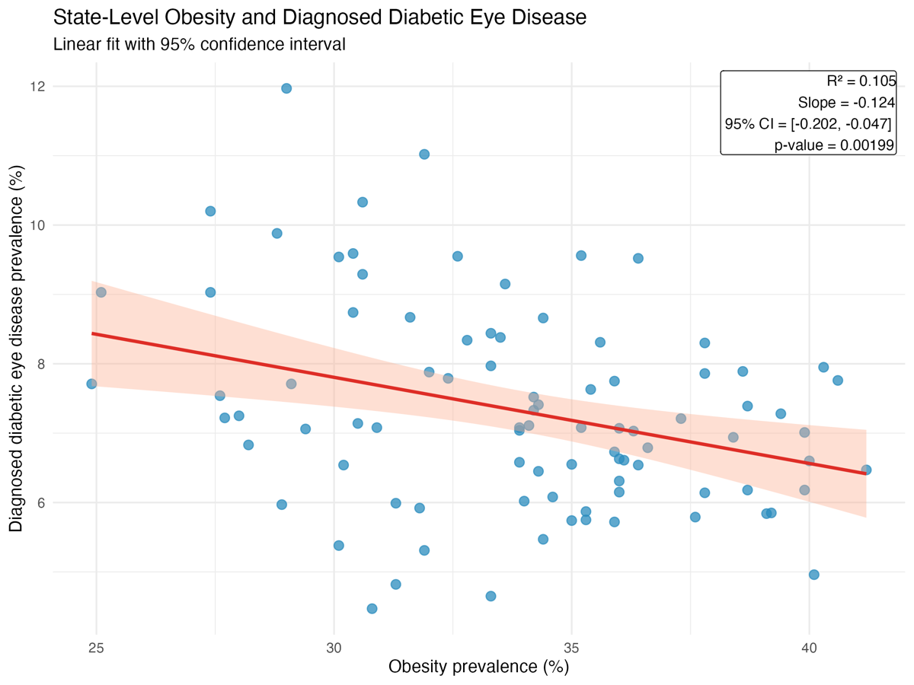
Figure 2. State-Level Adult Obesity and Diagnosed Diabetic Eye Disease Prevalence
This finding should be interpreted carefully. Obesity is an important risk factor for type 2 diabetes and related cardiometabolic conditions, so a simple expectation might be that states with higher obesity prevalence would also show higher diagnosed diabetic eye disease prevalence. However, the observed negative association likely reflects the limitations of ecological analysis and the mismatch between the two sources. The MarketScan dataset represents a commercially insured population, while the BRFSS obesity measure represents a broader state-level adult population. These two populations are not identical.
In addition, diagnosed diabetic eye disease prevalence in claims data depends not only on disease occurrence but also on diagnosis, screening, coding, and healthcare utilization. A state with better eye care access or more frequent screening might have higher diagnosed prevalence because more cases are detected. A state with worse access may have lower diagnosed prevalence even if the true underlying disease burden is high. Therefore, the weak negative association should not be interpreted as evidence that obesity protects against diabetic eye disease. Rather, it suggests that state-level obesity prevalence alone was not a strong ecological explanation for geographic variation in diagnosed diabetic eye disease in this commercially insured claim dataset.
The healthcare implication is that broad behavioral indicators may be insufficient to explain diagnosed eye disease patterns without additional measures of diabetes prevalence, glycemic control, screening access, insurance plan design, provider availability, and healthcare utilization. Future work should incorporate more specific diabetes-related and access-related variables.

Finding 3: Physical inactivity also showed a statistically significant but weak negative ecological association with diagnosed diabetic eye disease prevalence.
The third finding was like the obesity result. State-level physical inactivity prevalence showed a statistically significant but weak negative association with diagnosed diabetic eye disease prevalence. A 1 percentage-point increase in state-level physical inactivity prevalence was associated with an estimated 0.143 percentage-point decrease in diagnosed diabetic eye disease prevalence. The 95% confidence interval ranged from -0.218 to -0.068, and the p-value was less than 0.001. The Pearson correlation between physical inactivity prevalence and diagnosed diabetic eye disease prevalence was r = -0.38.
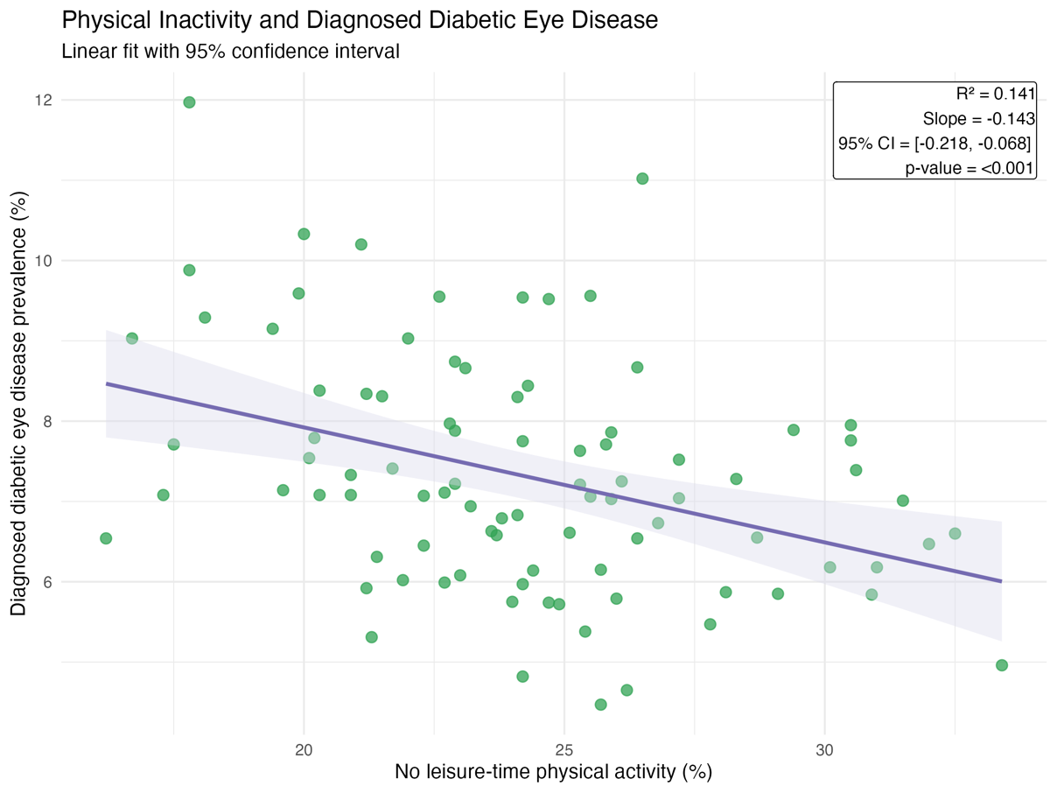
Figure 3. State-Level Physical Inactivity and Diagnosed Diabetic Eye Disease Prevalence
This result again highlights the difference between individual-level risk and state-level ecological correlation. Physical inactivity is relevant to diabetes prevention and management, but the BRFSS measure used in this project was a state-level self-reported behavioral indicator. It was not measured among the same individuals represented in the MarketScan claims data. Therefore, this finding cannot be used to conclude that inactive individuals had lower risk of diabetic eye disease. Instead, it suggests that the state-level behavioral environment, measured only by physical inactivity prevalence, did not explain much of the geographic variation in diagnosed diabetic eye disease prevalence.
The result also demonstrates an important methodological lesson. Combining public surveillance datasets can be useful for generating hypotheses, but merged aggregate data can produce patterns that are difficult to interpret. The ecological association may be influenced by differences in population composition, healthcare access, screening intensity, coding practices, and commercial insurance coverage. For example, states with lower physical inactivity may still have older commercially insured diabetic populations or stronger eye disease detection systems, leading to higher diagnosed prevalence.
The healthcare implication is that interventions should not be designed based only on these ecological correlations. Instead, the findings support the need for more detailed data that include individual diabetes status, duration of diabetes, glycemic control, blood pressure control, smoking status, eye exam history, and social determinants of health.

Finding 4: The correlation heatmap showed clustering between obesity and physical inactivity but limited explanatory value for diabetic eye disease prevalence.
The Pearson correlation heatmap summarized the relationships among diagnosed diabetic eye disease prevalence, adult obesity prevalence, and physical inactivity prevalence. Diagnosed diabetic eye disease prevalence was negatively correlated with adult obesity prevalence (r = -0.32) and physical inactivity prevalence (r = -0.38). Adult obesity and physical inactivity were positively correlated with each other (r = 0.69), suggesting that these two behavioral risk indicators tended to cluster together geographically.
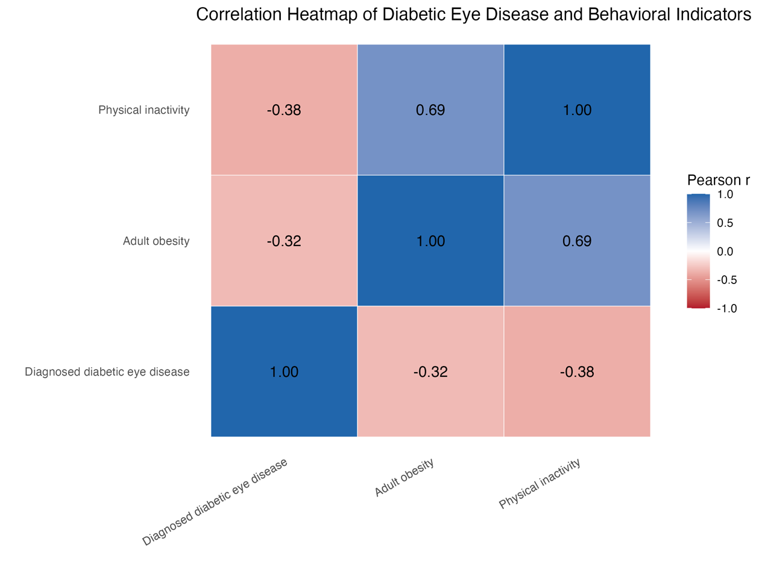
Figure 4. Pearson Correlation Heatmap of Diabetic Eye Disease and Behavioral Indicators
This finding supports the interpretation that broad state-level behavioral indicators alone did not explain much of the geographic variation in diagnosed diabetic eye disease prevalence among the commercially insured population. The positive correlation between obesity and physical inactivity was expected because both indicators reflect related behavioral and cardiometabolic risk environments. However, their negative correlations with diagnosed diabetic eye disease prevalence show why ecological findings must be interpreted cautiously. The outcome was claims-based diagnosed prevalence, not true disease prevalence, and diagnosis patterns may depend on healthcare access, screening, coding, and insurance utilization.

Data Gaps and Future work
This project had several important data gaps. First, the MarketScan dataset was an aggregate claims summary dataset rather than a patient-level dataset. As a result, it was not possible to conduct individual-level modeling, estimate adjusted risk ratios, or determine whether specific individuals with hypertension, tobacco use, obesity, or physical inactivity had higher risk of diagnosed diabetic eye disease.
Second, the MarketScan data represented commercially insured individuals and their dependents. The limits generalizability to people covered by Medicaid, Medicare, uninsured populations, and other groups with different healthcare access patterns. Because diabetic eye disease risk and screening access may differ across insurance types, future research should compare commercially insured populations with Medicaid and Medicare populations.
Third, The BRFSS supplementary dataset was based on self-reported survey data. Self-reported obesity and physical activity may include measurement error or reporting bias. In addition, the BRFSS population and MarketScan commercially insured population were not the same individuals, so the merged analysis was ecological rather than individual-level.
Fourth, the project lacked important clinical and access-related variables. Data on HbA1c, duration of diabetes, blood pressure control, medication use, eye exam frequency, ophthalmologist availability, rurality, income, and neighborhood deprivation would strengthen the analysis. Future work could use multilevel modeling to separate individual-level risk factors from state-level or county-level contextual factors.
Future research could also compare claims-based U.S. surveillance data with international aging cohort data, such as the China Health and Retirement Longitudinal Study. Although CHARLS is not directly comparable to the U.S. commercially insured MarketScan population, it could support future cross-national exploratory work on diabetes, visual impairment, chronic disease burden, and aging-related health disparities.

Conclusion
This project examined variation in diagnosed diabetic eye disease across risk-factor subgroups and geographic areas in a commercially insured population. Using the CDC Vision and Eye Health Surveillance System MarketScan Commercial Medical Insurance dataset as the primary source and the CDC BRFSS Nutrition, Physical Activity, and dataset as a supplementary source, the analysis describe state-level variation in diagnosed diabetic eye disease prevalence and explored ecological associations with obesity and physical inactivity.
The main contribution of the project is that is shows how claims-based surveillance data can be used to describe variation on diagnosed diabetic eye disease among commercially insured populations. The findings suggested substantial state-level variations in diagnosed prevalence. However, state-level obesity and physical inactivity showed weak negative ecological associations with diagnosed diabetics eye disease prevalence, suggesting that these behavioral indicators alone did not explain geographic variation in the claims-based outcome.
The project also demonstrates the importance of cautious interpretation when integrating public health surveillance datasets. Because the data were aggregate, claims-based, and not individual linked, the findings cannot support causal conclusions. Diagnosed prevalence may reflect screening, access, coding, and healthcare utilization as much as underlying disease burden. Future research should use more detailed patient-level or multilevel data to better understand how diabetes management, hypertension, tobacco use, social determinants, and healthcare access contribute to diabetic eye disease outcomes.
Overall, this project provides a descriptive exploratory foundation for understanding diabetic eye disease burden in commercially insured populations, It also highlights the need for more comprehensive data sources to guide targeted screening, prevention, and equitable eye care access.

Reference:
1. VEHSS Modeled Estimates: Prevalence of Diabetic Retinopathy (DR). In. Available from: https://www.cdc.gov/vision-health-data/prevalence-estimates/dr-prevalence.html
2. Lundeen EA, Burke-Conte Z, Rein DB, Wittenborn JS, Saaddine J, Lee AY, et al. Prevalence of Diabetic Retinopathy in the US in 2021. JAMA Ophthalmol. 2023 Aug 1;141(8):747. doi:10.1001/jamaophthalmol.2023.2289
3. About the Data: MarketScan. In. (Vision and Eye Health Surveillance System (VEHSS)). Available from: https://www.cdc.gov/vision-health-data/data-sources/marketscan.html
4. Nutrition, Physical Activity, and Obesity - Behavioral Risk Factor Surveillance System [Internet]. CDC. Available from: https://data.cdc.gov/Nutrition-Physical-Activity-and-Obesity/Nutrition-Physical-Activity-and-Obesity-Behavioral/hn4x-zwk7/about_data

